Fundamentals of computing

(CSA5731)

C program

_R. Sai pranathi

(192121149)

1. Generation of number series 1, 2, 3, 4,…..n

Input:

#include<stdio.h>

int main()

{

int i,n;

printf("input value of n");

scanf("%d",&n);

for(i=1;i<=n;i++)

{

printf("%d",i);

}

return 0;

}

Output :

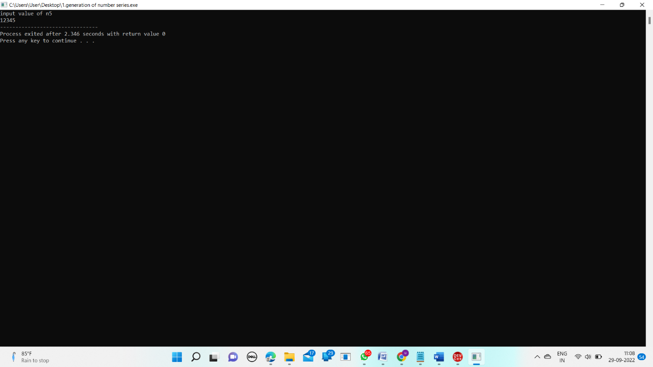

1. Generation of even number series 2, 4, 6, …..n

Input:

#include <stdio.h>

int main()

{

int i;

printf("program to print Even numbers");

for(i=1;i<20;i++)

{

i=i+1;

printf("%d",i);

}

return 0;

}

Output :

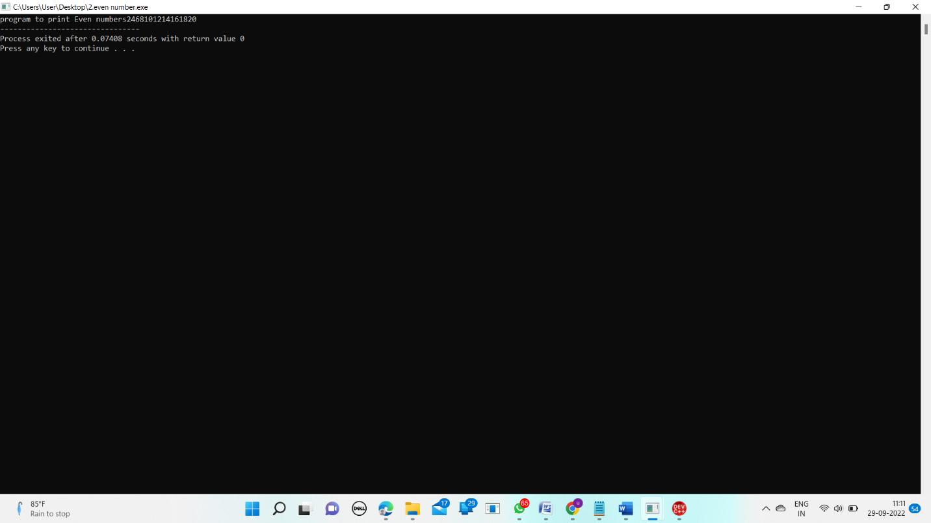

1. Generation of ODD number series 1, 3, 5, …..n

Input:

#include <stdio.h>

int main()

{

int i,n;

printf("enter the number");

scanf("%d",&n);

printf("odd numbers between 1 and %d are",n);

for(i=1;i<=n;i+=2)

{

printf("%d ",i);

}

return 0;

}

Output:

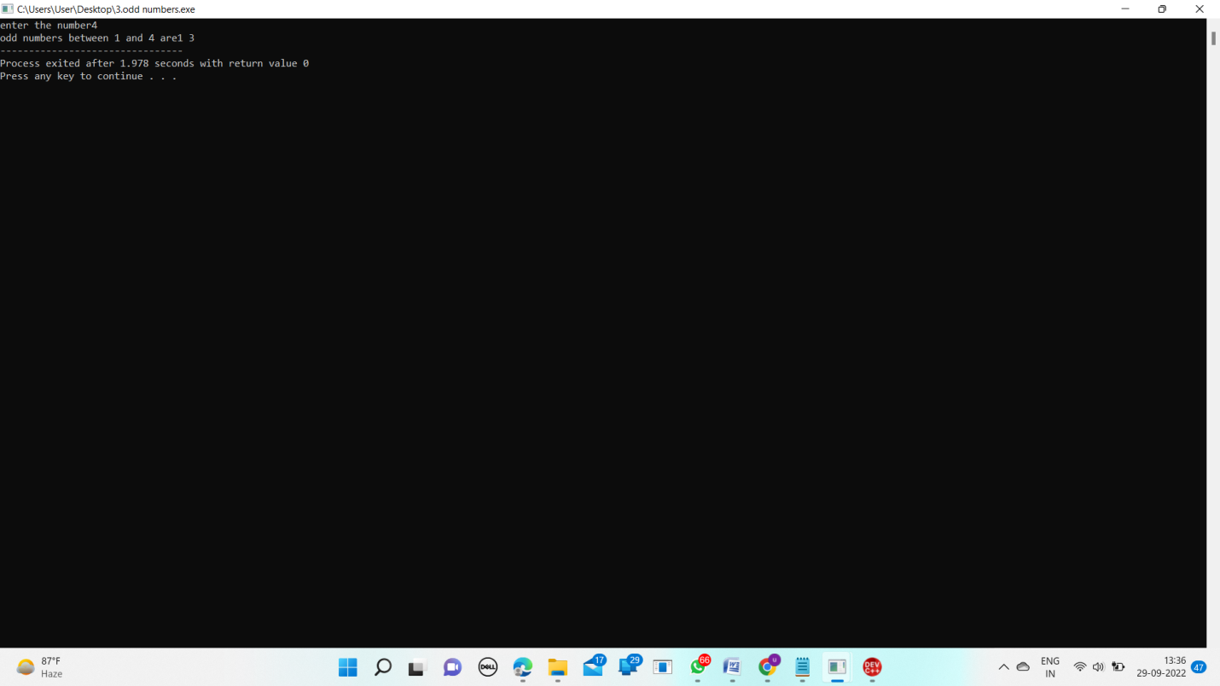

1. Generation of Fibonacci series 0, 1, 1, 2, 3, 5, 8, …..n

Input:

#include<stdio.h>

int main()

{

int n1=0,n2=1,n3,i,number;

printf("Enter the number of elements:");

scanf("%d",&number);

printf("\n%d %d",n1,n2);

for(i=2;i<number;++i)

{

n3=n1+n2;

printf(" %d",n3);

n1=n2;

n2=n3;

}

return 0;

}

Output:

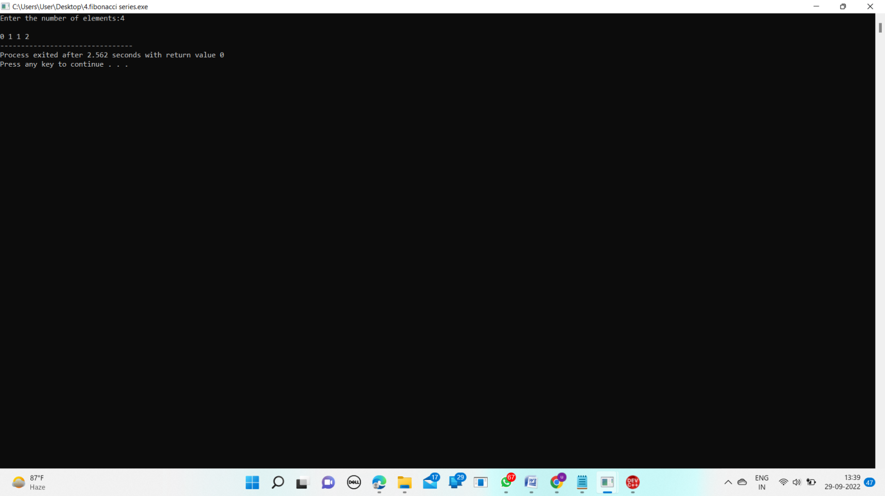

1. Summing up series 1 + 2 + 3 + 4….. +n

Input:

#include<stdio.h>

int main()

{

int n,i;

int sum=0;

printf("Enter the n i.e. max values of series: ");

scanf("%d",&n);

sum = (n * (n + 1)) / 2;

printf("Sum of the series: ");

for (i =1;i <= n;i++) {

if (i!=n)

printf("%d + ",i); else

printf("%d = %d ",i,sum);

}

return 0;

}

Output:

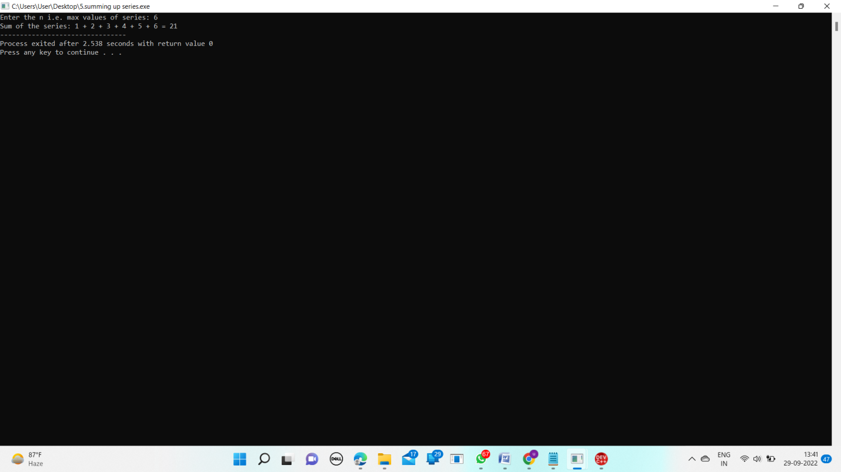

1. Summing up Even Number series

Input:

#include <stdio.h>

int main()

{

int i, n, sum=0;

printf("Enter any number: ");

scanf("%d", &n);

for(i=2; i<=n; i+=2)

{

sum += i;

}

printf("Sum of all even numbers from 1 to %d: %d", n, sum);

return 0;

}

Output: 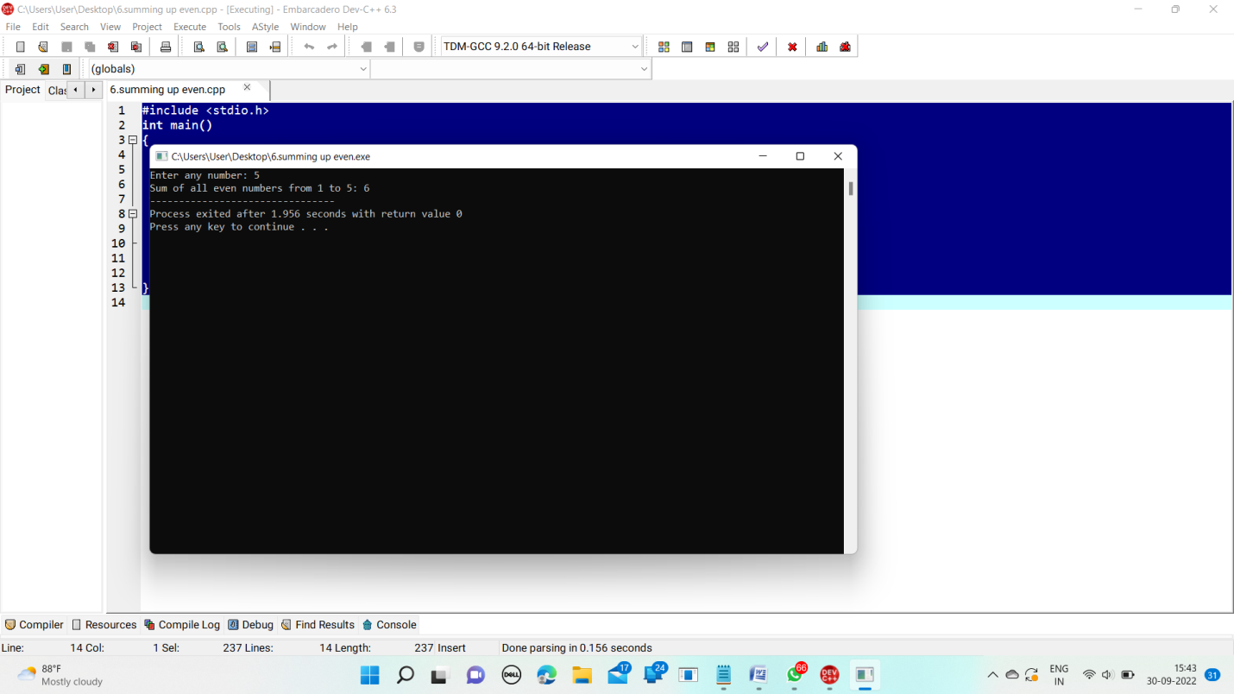

1. Summing up Even Number series

Input:

#include <stdio.h>

int main()

{

int i,num;

printf("Input number of terms : ");

scanf("%d", &num);

for(i=1;i<=num;i++)

{

printf("Number is : %d and cube of the %d is :%d ",i,i, (i*i*i));

}

return 0;

}

Output:

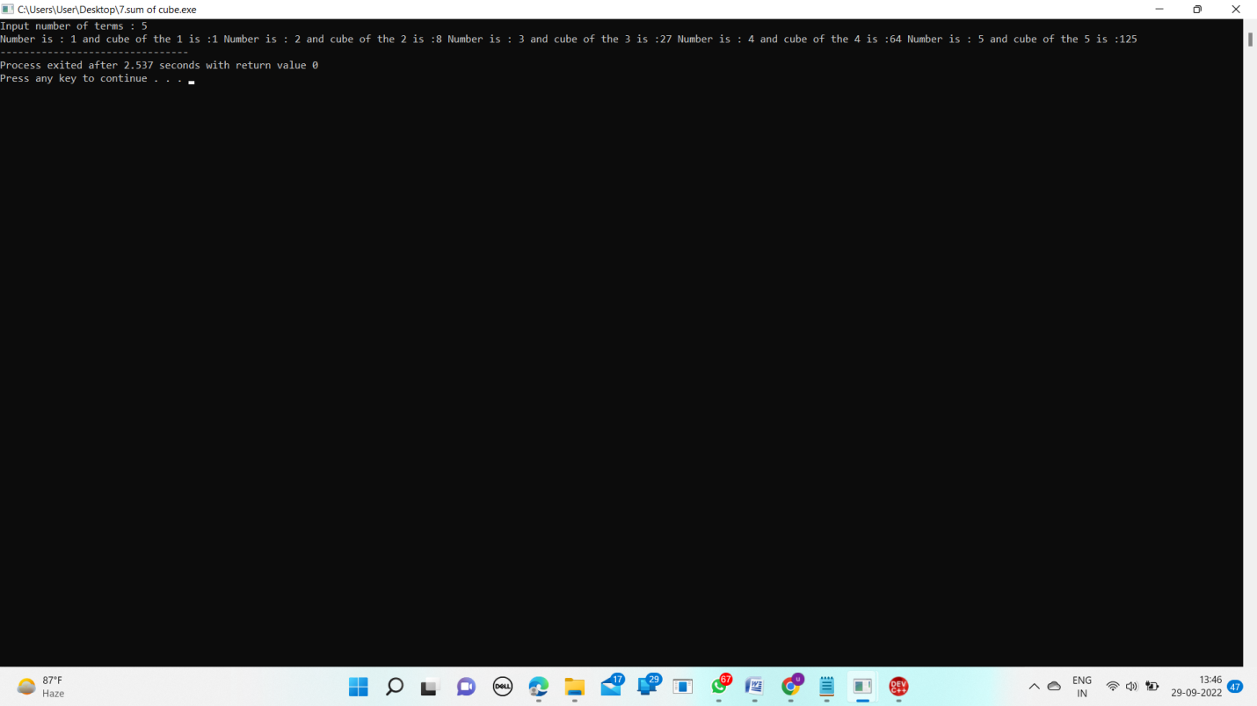

1. Finding whether the given integer is odd or even

Input:

#include<stdio.h>

int main()

{

int num;

printf("enter the number");

scanf("%d",&num);

if(num % 2 == 0)

printf("even");

else

printf("odd");

return 0;

}

Output:

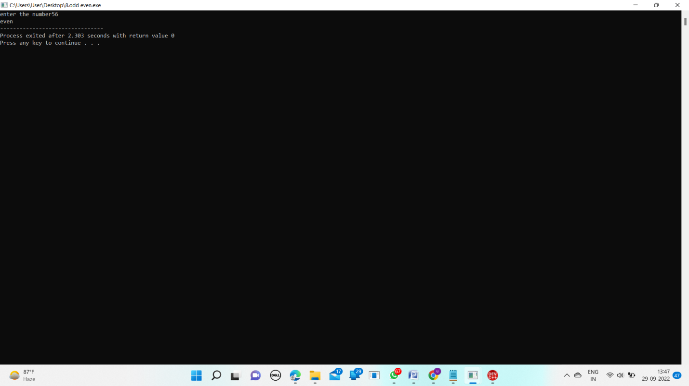

1. Product series (Factorial of a given number)

Input:

int main()

{

int i,fact=1,number;

printf("Enter a number: ");

scanf("%d",&number);

for(i=1;i<=number;i++)

{

fact=fact*i;

}

printf("Factorial of %d is: %d",number,fact);

return 0;

}

Output:

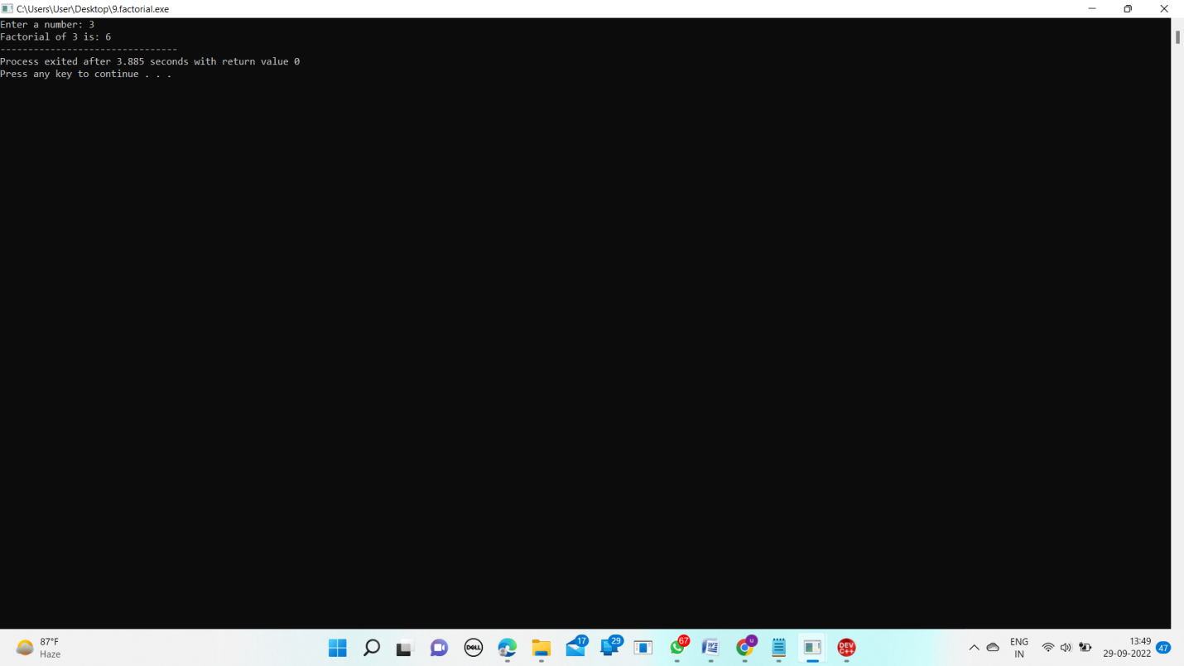

1. Finding given number is Armstrong or not

Input:

#include <stdio.h>

int main() {

int num, originalNum, remainder, result = 0;

printf("Enter a three-digit integer: ");

scanf("%d", &num);

originalNum = num;

while (originalNum != 0) {

remainder = originalNum % 10;

result += remainder * remainder * remainder;

originalNum /= 10;

}

if (result == num)

printf("%d is an Armstrong number.", num);

else

printf("%d is not an Armstrong number.", num);

return 0;

}

Output:

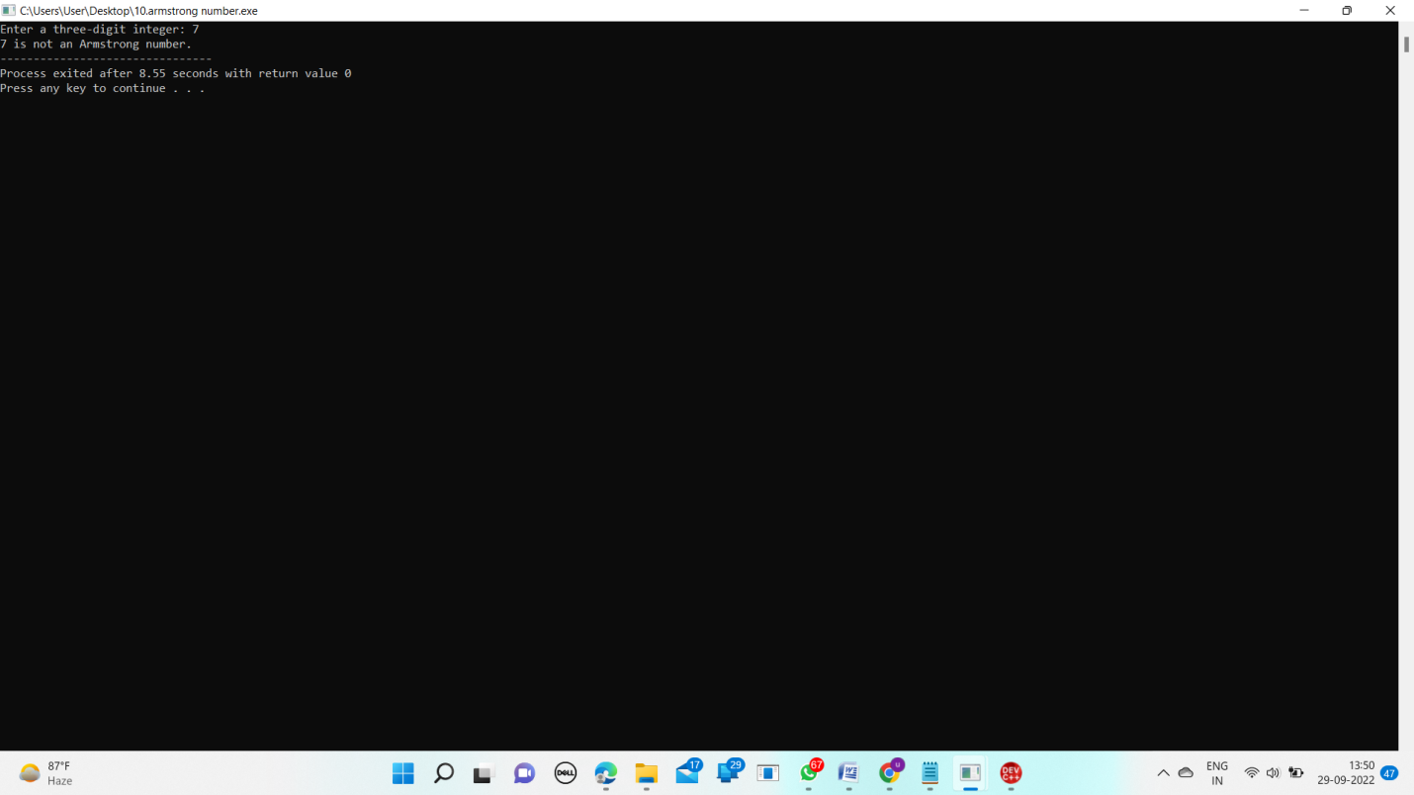

1. Summing up any n numbers and finding average

Input:

#include<stdio.h>

int main( )

{

int n, count = 1;

float x, average, sum = 0;

printf("Enter the value of n ");

scanf ("%d",&n);

while (count <= n)

{

printf ("Enter the %d number ",count);

scanf("%d", &x);

sum += x;

++count;

}

average = sum/n;

printf("\nThe Average is %f\n", average);

return 0;

}

Output:

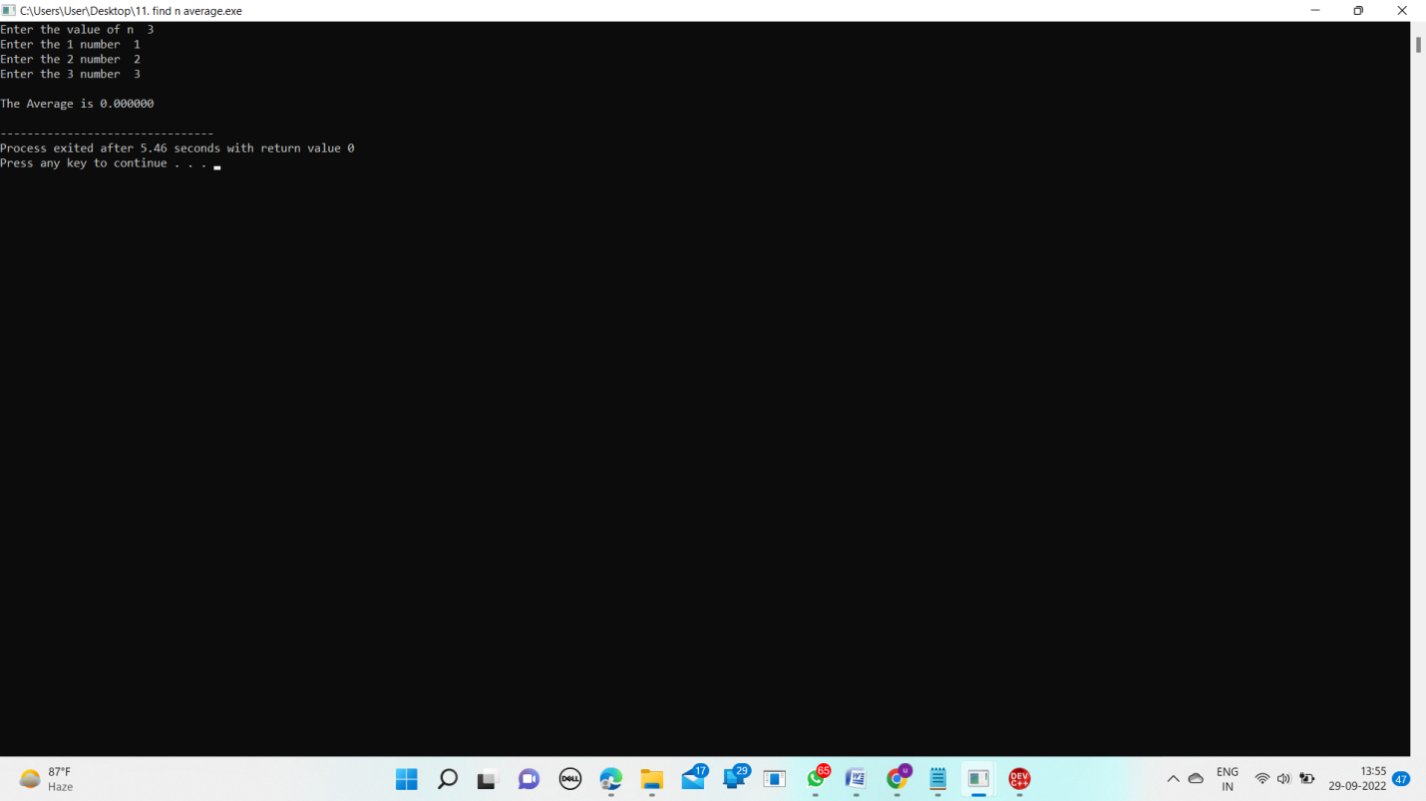

1. Printing digits of an integer number

Input:

#include <stdio.h>

int main() {

int number;

printf("Enter an integer:");

scanf("%d",&number);

printf("You entered: %d",number);

return 0;

}

Output:

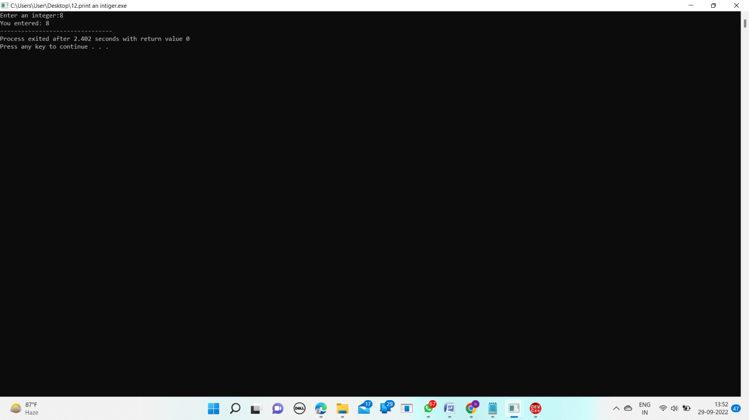

1. Summing up the digits of an integer number

Input:

#include<stdio.h>

int main()

{

int n,sum=0,m;

printf("Enter a number:");

scanf("%d",&n);

while(n>0)

{

m=n%10;

sum=sum+m;

n=n/10;

}

printf("Sum is=%d",sum);

return 0;

}

Output:

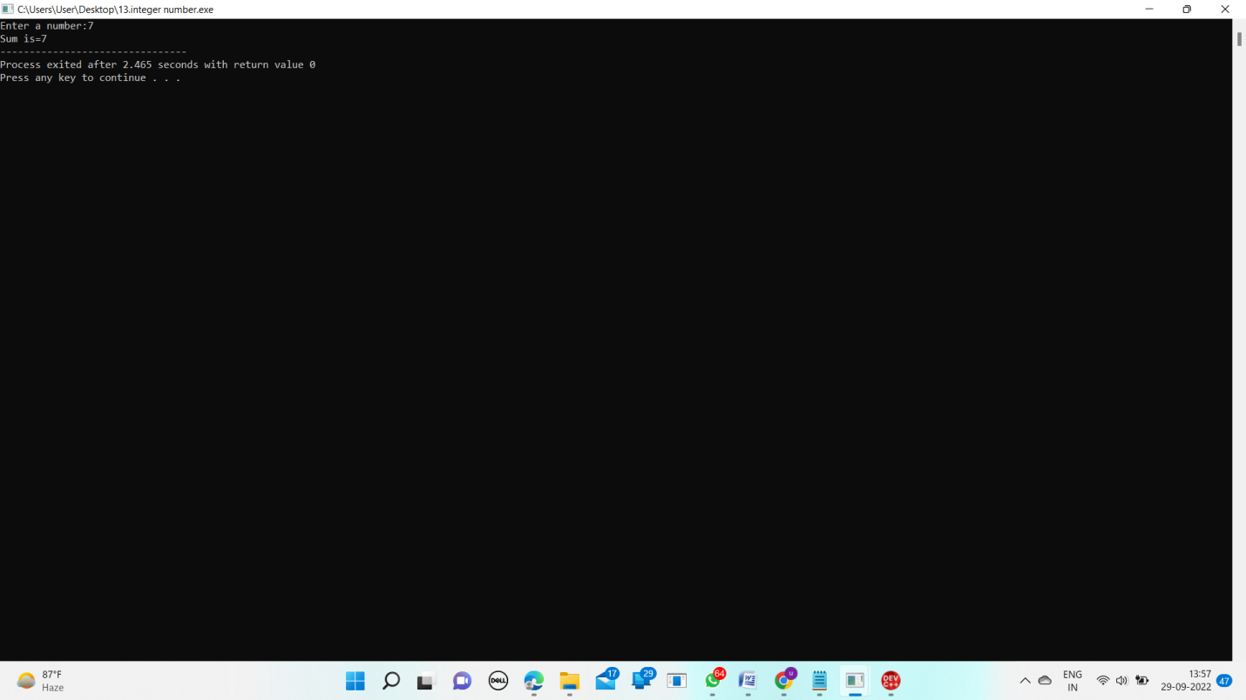

1. Reversing the digits of an integer number

Input:

#include<stdio.h>

int main()

{

int n, reverse=0, rem;

printf("Enter a number: ");

scanf("%d", &n);

while(n!=0)

{

rem=n%10;

reverse=reverse*10+rem;

n/=10;

}

printf("Reversed Number: %d",reverse);

return 0;

}

Output:

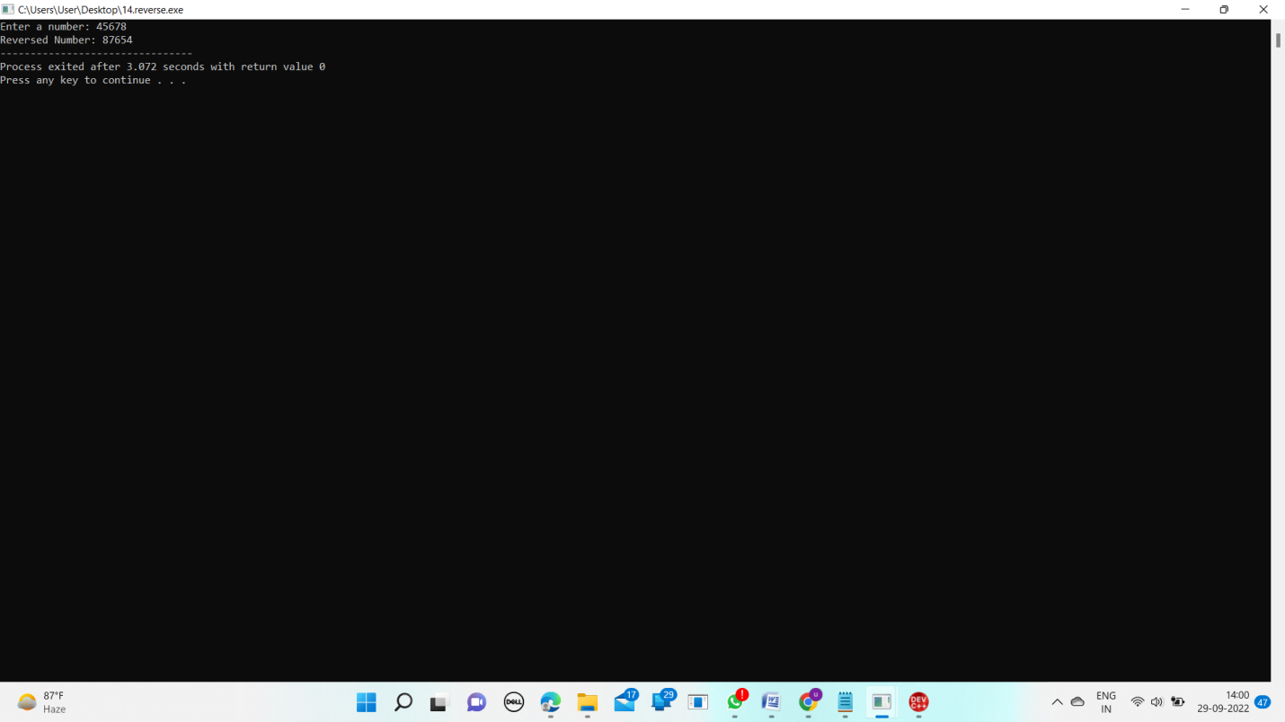

1. Reversing the digits of an integer number

Input:

#include <stdio.h>

int main()

{

int num;

printf("Input a number :");

scanf("%d", &num);

if (num >= 0)

printf("%d is a positive number ", num);

else

printf("%d is a negative number ", num);

return 0;

}

Output:

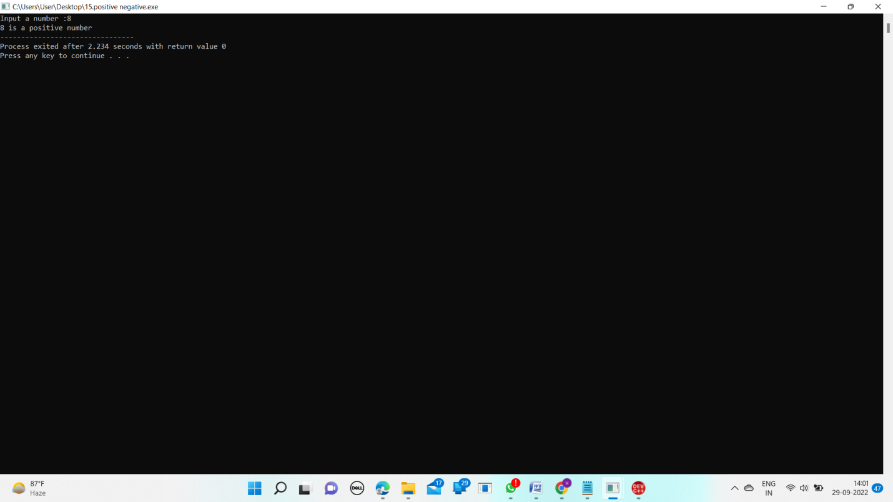

1. Swapping two numbers with a temporary variable

Input:

#include<stdio.h>

int main()

{

int x,y;

printf("Enter Value of x ");

scanf("%d", &x);

printf("\nEnter Value of y ");

scanf("%d", &y);

int temp = x;

x=y;

y=temp;

printf("After Swapping:x=%d,y=%d",x,y);

return 0;

}

Output:

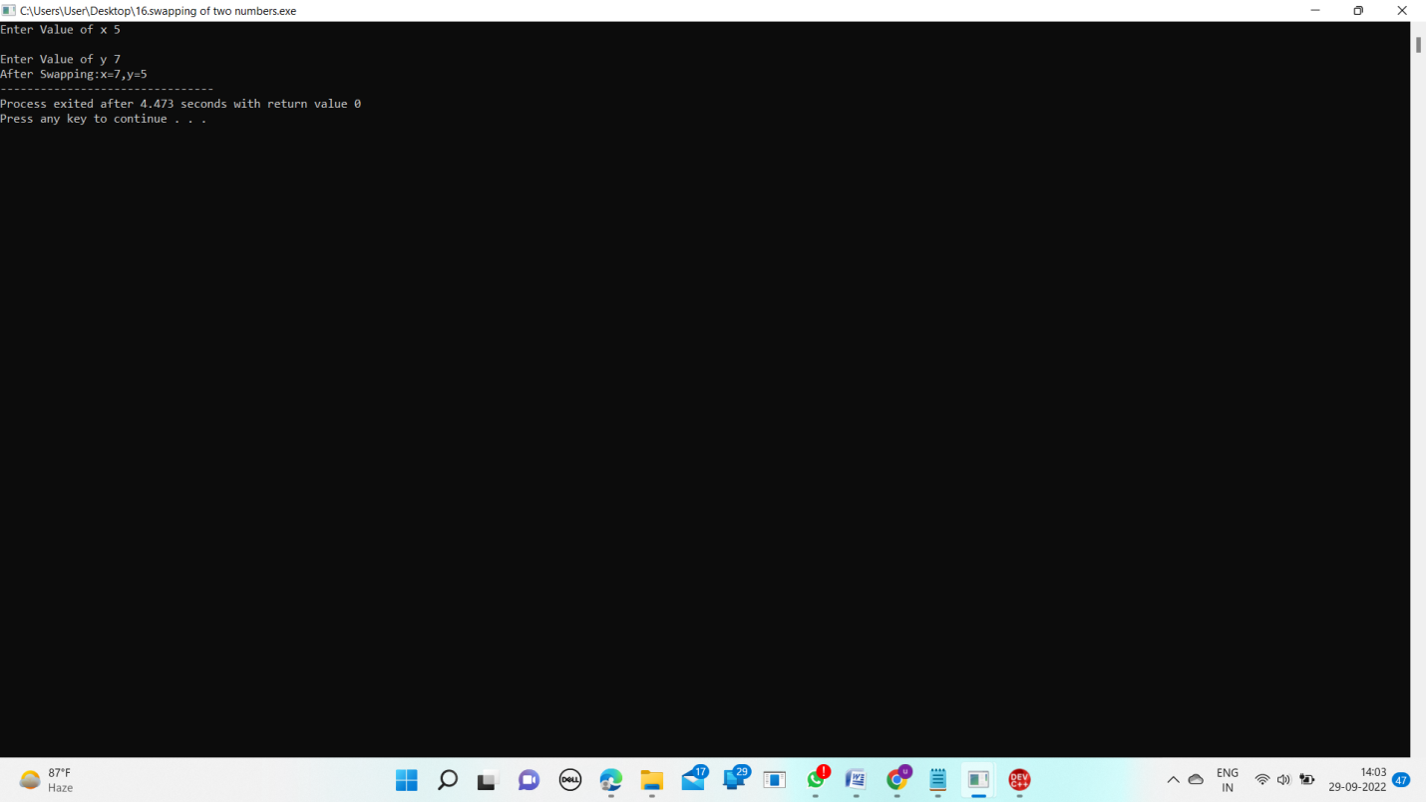

1. Program to convert decimal to hexadecimal

Input:

conversion_table = ['0', '1', '2', '3', '4', '5', '6', '7', '8', '9', 'A' , 'B', 'C', 'D', 'E', 'F']

decimal = int(input("Enter a number: "))

hexadecimal = ''

while(decimal>0):

remainder = decimal%16

hexadecimal = conversion_table[remainder]+ hexadecimal

decimal = decimal//16

print("Hexadecimal: ",hexadecimal)

Output:

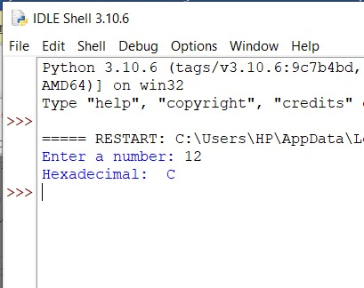

1. Program to convetHexa to decimal

Input:

print("Enter the Hexadecimal Number: ")

hexdecnum = input()

chk = 0

decnum = 0

hexdecnumlen = len(hexdecnum)

hexdecnumlen = hexdecnumlen-1

i = 0

while hexdecnumlen>=0:

rem = hexdecnum[hexdecnumlen]

if rem>='0' and rem<='9':

rem = int(rem)

elif rem>='A' and rem<='F':

rem = ord(rem)

rem = rem-55

elif rem>='a' and rem<='f':

rem = ord(rem)

rem = rem-87

else:

chk = 1

break

decnum = decnum + (rem * (16 ** i))

hexdecnumlen = hexdecnumlen-1

i = i+1

if chk == 0:

print("\nEquivalent Decimal Value: ", decnum)

else:

print("\nInvalid Input!")

Output:

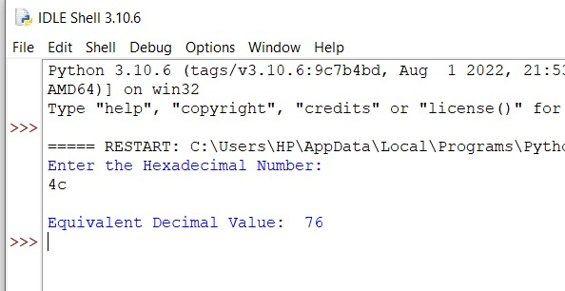

1. Program to convert decimal to octal

Input:

print("enter the number")

def decToOctal(n):

octalNum = [0] * 100

i = 0

while (n != 0):

octalNum[i] = n % 8

n = int(n / 8)

i += 1

for j in range(i - 1, -1, -1):

print(octalNum[j], end="")

n=44

decToOctal(n)

Output:

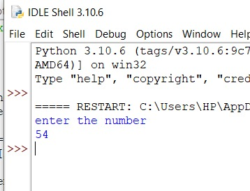

1. Program to convert octal to decimal

Input:

print("Enter the Octal Number: ")

octnum = int(input())

chk = 0

i = 0

decnum = 0

while octnum!=0:

rem = octnum%10

if rem>7:

chk = 1

break

decnum = decnum + (rem * (8 ** i))

i = i+1

octnum = int(octnum/10)

if chk == 0:

print("\nEquivalent Decimal Value =", decnum)

else:

print("\nInvalid Input!")

Output:

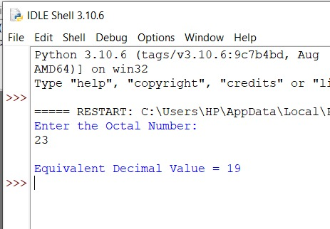

1. Program to convert binary to decimal

Input:

b_num = list(input("Input a binary number: "))

value = 0

for i in range(len(b_num)):

digit = b_num.pop()

if digit == '1':

value = value + pow(2, i)

print("The decimal value of the number is", value)

Output:

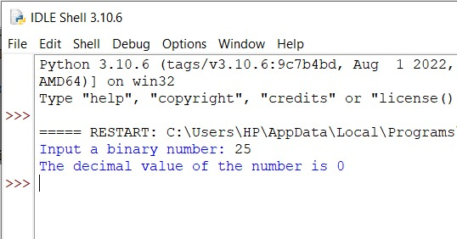

1. Write a program for binary multiplication

Input:

print("Enter First Binary Number: ")

binOne = int(input())

print("Enter Second Binary Number: ")

binTwo = int(input())

binOne = str(binOne)

binTwo = str(binTwo)

decMul = int(binOne, 2) * int(binTwo, 2)

binMul = bin(decMul)

print("\nResult = " + binMul)

Output:

